PROGRAM 1 & 2 :
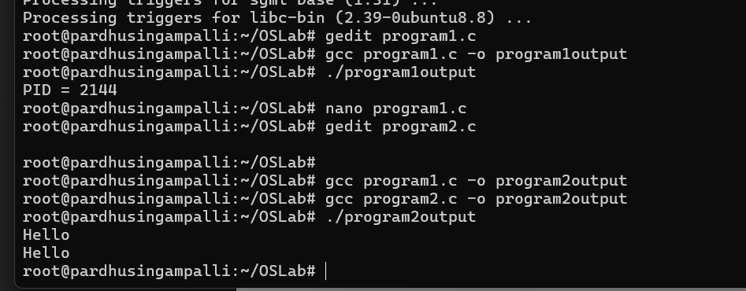
Program 3:
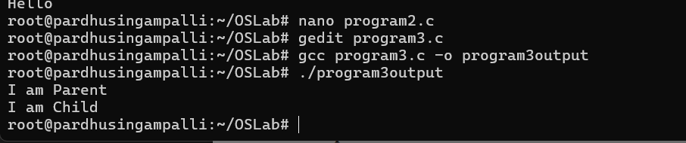
Program 4:
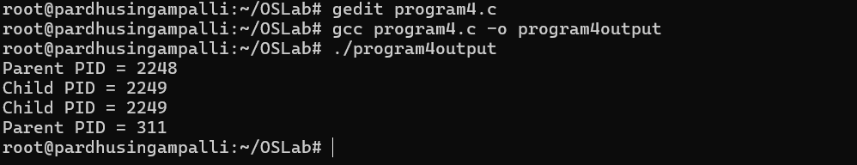
Program 5:
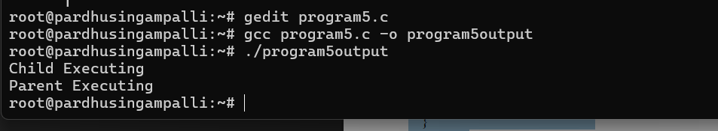
Program 6:
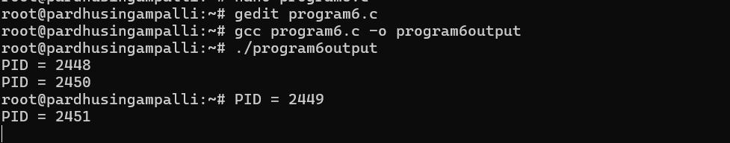
Program 7:
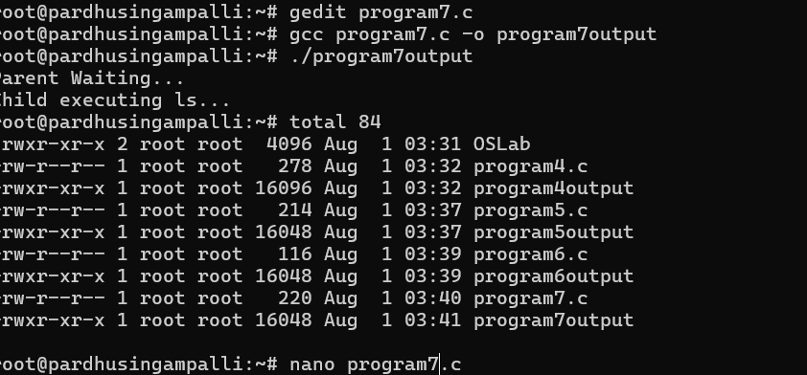
Program 10:
